WORK-CASE №2

***Готував матеріал студент Мішин А.О.***

1.Install a type II hypervisor on your home workstation - Virtual Box, VMWare Workstation, Hyper-V (or another one of your choice).

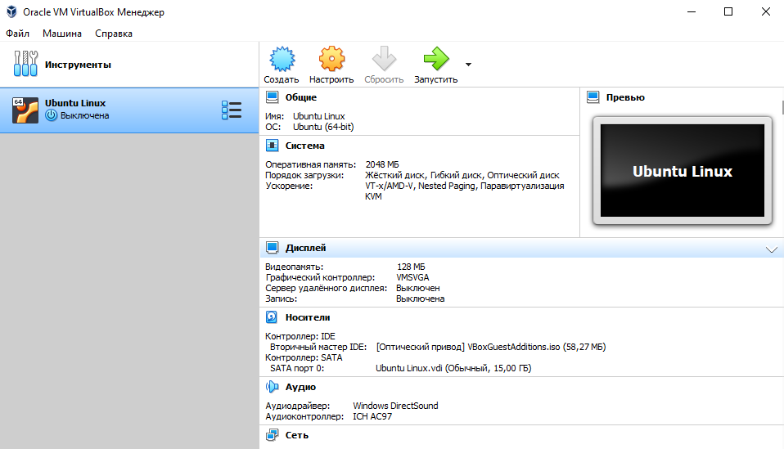

I installed Virtual Box:

 2.Describe a set of basic actions in the hypervisor you installed:

Here is a set of basic actions in VirtualBox:

* Create a new virtual machine:

Start VirtualBox on your computer.

In the upper-left corner of the window, click File and select New Virtual Machine.

In the virtual machine creation wizard, you will enter a machine name, select the type of operating system, and determine the amount of RAM.

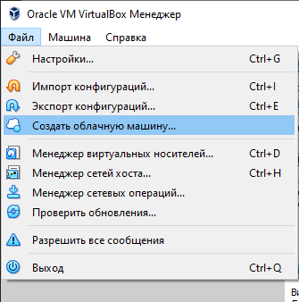

* Select/add available hardware:

After creating a virtual machine, select it from the list of available machines in the VirtualBox main window.

Right-click on the selected machine and select Settings.

In the machine settings window, you can configure various settings, such as the size of the virtual hard disk, the number of processors, the video card, and other hardware.

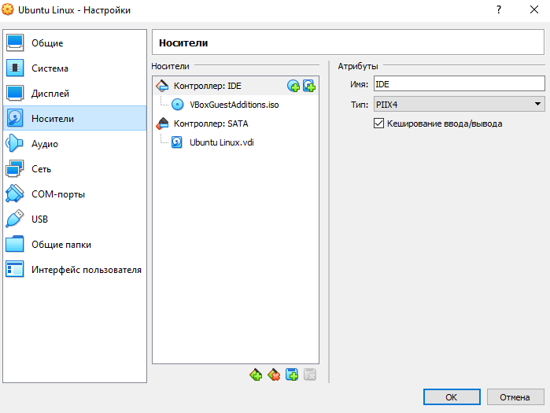

* Configure network settings and connect to Wi-Fi points:

In the virtual machine settings window, go to the Network section.

Here you can select a connection type, such as "Adapter 1," which will allow the virtual machine to access your computer's local network.

If you need to connect the machine to a Wi-Fi point, you can configure the network so that it uses a wireless adapter.

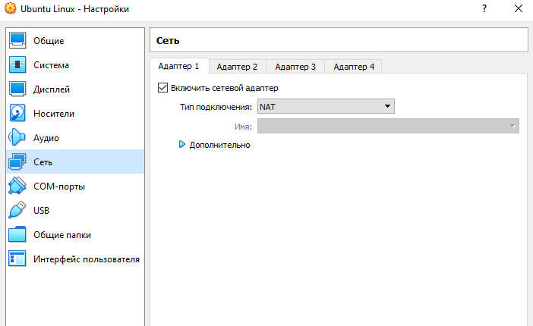

* Ability to work with external media (flash memory):

Turn on the virtual machine to which you want to connect external media.

In the main menu, select Devices and then USB.

Here you will see a list of available USB devices that can be connected to the virtual machine. Select the device you want to connect.

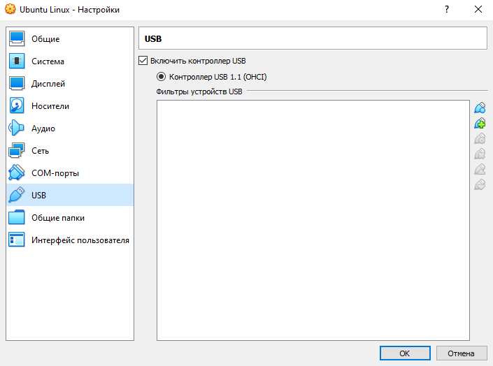

3.

Install the GNU/Linux CentOS operating system (or another convenient distribution) in your hypervisor in a basic configuration with a graphical shell.

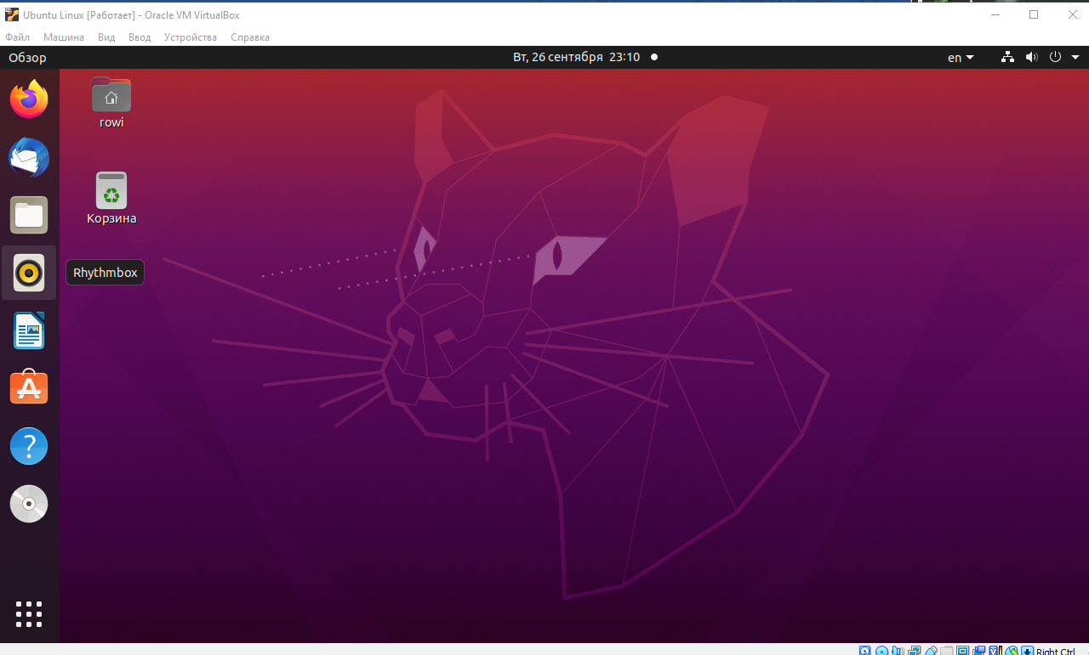

I installed Ubuntu Linux